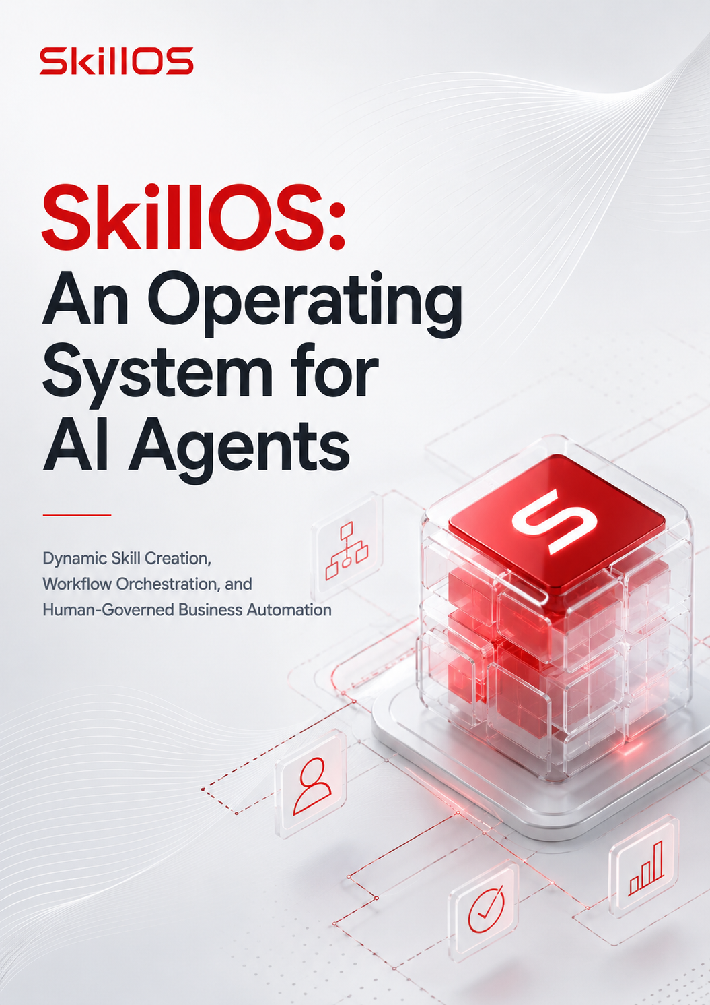

Table of Contents

1. Abstract 1
2. Introduction 1
3. Key Features 2
4. System Architecture 3
5. Design Principles 4
6. Core Components 4
7. Execution Workflow 5
8. Demonstration Scenarios 6
9. Experiments 6
10. Limitations 7
11. Future Work 8
12. Conclusion 8
References 9

SkillOS: An Operating System for AI Agents
  - Dynamic Skill Creation, Workflow Orchestration, and Human-Governed Business Automation
Track: Agent for Business
Author: H. Serdar Altan
Date: July 3, 2026

1. Abstract
Large Language Models (LLMs) can perform a wide range of business tasks, yet many current agent architectures still rely on predefined tools and capabilities. Consequently, requests outside an agent’s available toolset may require additional implementation or developer intervention. This is especially limiting for startups, where requirements change quickly and teams need fast, low-cost execution.
SkillOS is not an operating system in the traditional sense. Rather, it is an orchestration framework that provides operating-system-like services for AI agents by treating AI capabilities as reusable, discoverable skills managed within a structured operating environment. It plans workflows, reuses existing skills whenever possible, generates new skills when needed, validates them before registration, and executes approved skills through runtime modules.
By combining workflow planning, skill creation, registry-based orchestration, structured outputs, runtime execution, and Model Context Protocol (MCP) integration, SkillOS provides a practical framework for AI-assisted business automation.

2. Introduction
Businesses increasingly expect AI agents to do more than answer questions. They want systems that can generate reports, build websites, design marketing assets, initialize software projects, analyze data, publish repositories, and coordinate multi-step workflows.
However, many AI agents remain reactive. They execute only the tools originally provided by developers. If a requested capability is unavailable, additional development is often required before execution can continue. For startups, where requirements evolve rapidly, this creates unnecessary delay.
SkillOS reduces this limitation by treating each capability as an independent reusable skill. Existing skills are discovered through a central registry. When no suitable capability exists, SkillOS can generate a new skill, validate it, and make it available for future workflows.
For startups, this provides practical value: faster prototyping, reduced engineering effort, repeatable workflows, reusable business capabilities, and human oversight before capability expansion.
Rather than manually coordinating multiple AI tools, users describe a business objective. SkillOS then plans and executes the workflow through a controlled pipeline.

3. Key Features
SkillOS provides several capabilities that distinguish it from conventional AI agent workflows.
Dynamic Skill Creation
When a required capability does not already exist, SkillOS can generate a new production-ready skill instead of relying solely on predefined functionality.
Workflow Planning
Complex user requests are automatically decomposed into ordered execution steps, allowing multi-stage tasks to be coordinated through a single workflow.
Reusable Skill Library
Approved skills are stored for future use, enabling previously generated capabilities to be reused across multiple workflows.
Human Approval
Newly generated skills require explicit user approval before becoming permanent capabilities.
LLM-as-Judge
Generated skills are automatically evaluated against configurable quality rubrics before human review.
Structured Outputs
Runtime-enabled skills produce validated JSON outputs using Pydantic schemas, improving interoperability between workflow stages.
Runtime Execution
Operational tasks are executed through dedicated runtime modules rather than directly by the generated skills.
MCP Integration
SkillOS communicates with external services through the Model Context Protocol (MCP). In the current implementation, GitHub MCP supports repository creation, file updates, and website publishing.

4. System Architecture
SkillOS consists of cooperating components rather than one autonomous agent. Each component has a defined role, making the architecture modular and easier to extend.
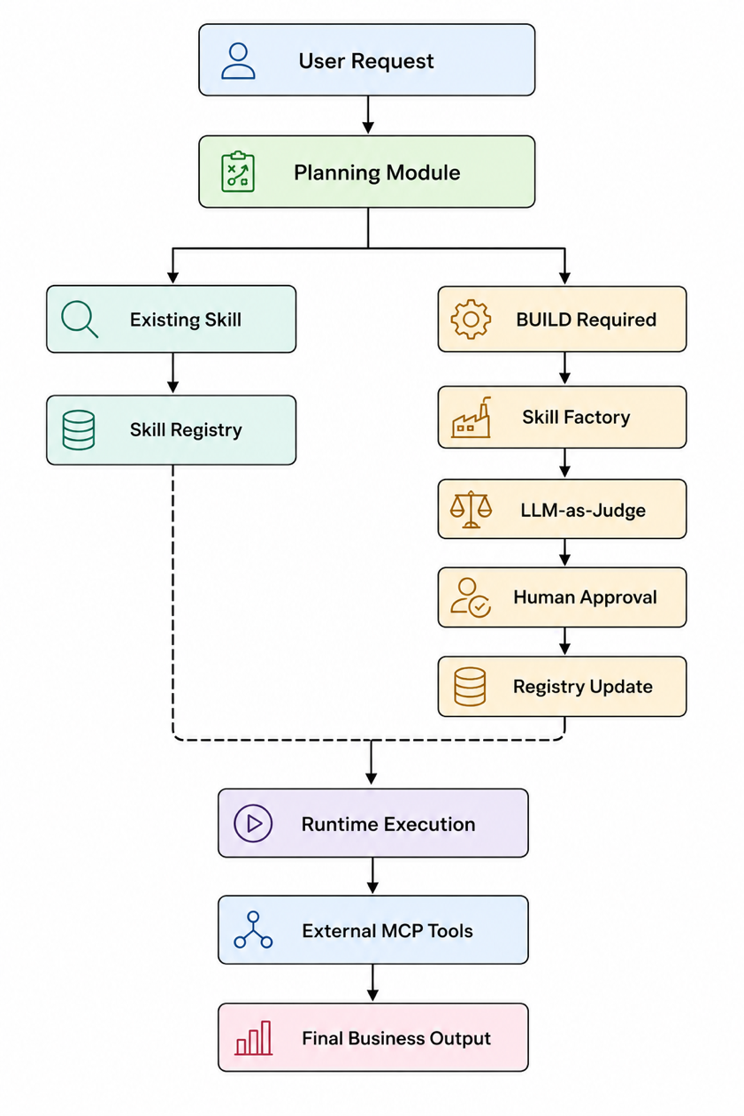
The Planner converts user requests into executable steps. The registry supports skill discovery. Missing capabilities are generated through the Skill Factory. Runtime modules perform operational execution, while MCP integrations connect SkillOS to external systems.
This separation improves maintainability, security, and long-term extensibility.

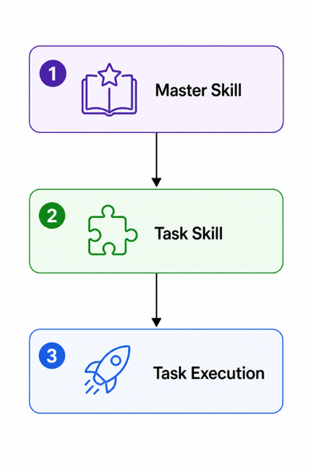
This workflow illustrates how SkillOS transforms general knowledge into executable capabilities. Instead of relying on a large collection of manually written skills, SkillOS starts with a reusable Master Skill that defines the general knowledge, reasoning patterns, and best practices for a capability.
When a user submits a specific request, SkillOS dynamically creates a Task Skill derived from the Master Skill. The generated Task Skill contains instructions tailored to the user’s particular task while preserving the overall design and quality standards defined by the Master Skill.
Finally, SkillOS executes the generated Task Skill to complete the requested task and produce the final output. Once created, the Task Skill can also be stored in the skill registry and reused in future workflows without being generated again.
This hierarchical approach enables SkillOS to continuously expand its capability library while keeping the number of manually maintained skills small. Rather than creating every skill by hand, developers define reusable Master Skills, and SkillOS automatically specializes them into Task Skills whenever new requirements arise. This makes the system scalable, maintainable, and capable of adapting to previously unseen tasks.

5. Design Principles
SkillOS is guided by a small set of architectural principles intended to improve reliability, maintainability, and responsible automation.
Reusable Capabilities
Instead of treating prompts as one-time solutions, SkillOS represents capabilities as reusable skills that can participate in future workflows.
Planning Before Execution
User requests are planned before execution begins. Separating planning from execution makes workflows easier to understand, reproduce, and extend.
Human-Centered Automation
Organizations retain control over capability expansion through mandatory approval of newly generated skills before they become permanent assets.
Separation of Responsibilities
Skill generation defines what should be done, while runtime modules determine how it is executed. This separation improves modularity and simplifies maintenance.
Structured Communication
Workflow stages exchange structured data rather than unrestricted natural-language responses, reducing ambiguity and improving reliability.

6. Core Components
SkillOS consists of several cooperating components, each responsible for a specific stage of the workflow.
Planning Module
The Planning Module analyzes the user’s request and converts it into an ordered execution plan. For each step, it determines whether an existing skill can be reused or whether a new one must be generated.
Skill Factory
When the planner identifies a missing capability, the Skill Factory generates a production-ready SKILL.md draft containing the metadata and instructions required to define the new skill.
Skill Registry
The Skill Registry maintains searchable metadata describing all approved skills, allowing the planner to discover existing capabilities before creating new ones.
LLM-as-Judge
The LLM-as-Judge evaluates newly generated skills using configurable rubrics that assess aspects such as metadata completeness, workflow quality, safety constraints, and structural consistency.
Human Approval Gate
Before a generated skill can be registered, the user reviews the draft and explicitly approves or rejects it. Only approved skills become permanent members of the registry.
Runtime Modules
Runtime modules perform operational tasks such as project initialization, webpage generation, image generation, report generation, and GitHub publishing. They execute structured runtime commands produced by the corresponding skills.
MCP Integration
The MCP layer enables SkillOS to interact with external systems. In the current implementation, GitHub MCP allows SkillOS to create repositories, update files, and publish generated web projects while keeping these operations separate from the core orchestration logic.

7. Execution Workflow
Every SkillOS workflow follows a deterministic execution pipeline.
Outputs from each workflow step become contextual input for subsequent stages.
Consider the following user request:
“Write a report on the given financial data, summarize the report, and translate the summary into Spanish.”
The Planning Module decomposes this request into the following execution plan:
- Report Generation
- Report Summarization
- Translation

8. Demonstration Scenarios
SkillOS was evaluated using several startup-oriented business scenarios.
Brand Name Generator
Generates multiple startup brand names.
Web Page Generator
Creates complete HTML, CSS, and JavaScript through structured runtime commands.
Report Generator
Accepts structured datasets such as JSON, dictionaries, Pandas DataFrames, and CSV files to produce business reports.
Project Initializer
Converts natural-language setup requests into structured runtime commands describing the required project directory structure.
GitHub Publishing
Uses GitHub MCP to create repositories, upload generated files, and publish web projects after explicit user approval.
These scenarios illustrate how skills can be created once and invoked later in different workflows.

9. Experiments
The experiments evaluated the SkillOS architecture rather than comparing foundation models. The objective was to test workflow planning, dynamic skill creation, human approval, runtime execution, and external integration.
Workflow Planning
Compound business requests containing multiple tasks were decomposed into logically ordered execution plans. Later steps could use outputs produced by earlier steps.
Structured Output Validation
Runtime-enabled skills generated outputs validated against predefined Pydantic schemas, reducing ambiguity between workflow stages.
Dynamic Skill Creation
The complete capability creation pipeline was evaluated:
- Generate a new skill.
- Evaluate it using the LLM-as-Judge.
- Request human approval.
- Register the approved skill.
- Reuse the capability in future workflows.
These experiments showed that new capabilities can be generated, validated, registered, and reused without manual implementation.

10. Limitations
Although SkillOS provides a flexible architecture for AI orchestration, several limitations remain.
Dependence on Foundation Models. Generated skill quality depends on the underlying models, API limits, service availability, and server reliability.
Prompt Engineering. Skill generation and workflow planning depend on prompt quality. More standardized and domain-specific prompts could improve consistency.
Workflow Execution. The current implementation separates skill generation from task execution. A more integrated workflow would generate, validate, register, and execute missing skills without requiring separate invocation.
Sequential Execution. The workflow engine currently executes tasks sequentially, favoring determinism over speed.
Limited Runtime Library. Existing runtime modules cover representative scenarios, but additional runtimes would expand supported applications.
External Service Availability. MCP operations depend on third-party APIs and may be affected by authentication failures, rate limits, or outages.
Registry Scalability. The current YAML registry is simple and transparent, but larger deployments may require database-backed indexing and version management.

11. Future Work
SkillOS was designed as a modular architecture capable of continuous evolution.
Parallel Workflow Execution
Future versions will identify independent workflow branches and execute them concurrently.
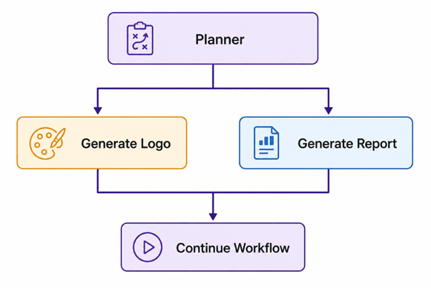
Additional planned improvements include:
- semantic skill versioning,
- more reliable workflow execution,
- fully integrated end-to-end execution,
- enhanced prompt engineering,
- persistent organizational memory,
- automatic recovery from transient failures,
- multi-agent collaboration,
- broader MCP integrations, including Google Workspace, Microsoft 365, Slack, Jira, Salesforce, CRM systems, cloud providers, and enterprise databases.
These enhancements are intended to increase scalability while preserving the core architecture.

12. Conclusion
SkillOS addresses one limitation of current AI agents: their reliance on fixed capabilities. By combining workflow planning, reusable skills, runtime execution, and controlled capability expansion, it provides a structured approach to AI-assisted business automation.
This approach is relevant for startups because small teams can describe business objectives in natural language while gradually building a reusable library of organizational capabilities.
Human approval and automated evaluation help ensure that newly generated skills are reviewed before becoming part of the permanent skill library.
Overall, SkillOS shows how reusable skills, structured workflows, and MCP-enabled integrations can be combined into a practical framework for orchestrating AI-assisted business tasks.

Links
Kaggle: https://www.kaggle.com/code/hserdaraltan/skillos-a-business-startup-use-case
GitHub: https://github.com/hsaltan/Machine-Learning/tree/main/SkillOS/notebook
YouTube: https://youtu.be/0nMIZEJK7B4

References
- Anthropic. Model Context Protocol (MCP). https://modelcontextprotocol.io
- Google. Agent Development Kit (ADK). https://google.github.io/adk-docs/
- Google. Gemini API Documentation. https://ai.google.dev/
- OpenAI. OpenAI API Documentation. https://platform.openai.com/docs/
- Pydantic Documentation. https://docs.pydantic.dev/
- Hugging Face. Diffusers Documentation. https://huggingface.co/docs/diffusers/en/index
- Kaggle. Google – The Gemma 3n Impact Challenge. https://www.kaggle.com/competitions/google-gemma-3n-hackathon

